**Home Work 2 : Fluid Dynamics AE2202**

**February, 12th 2020**

**Solve all problems**

**\*Hint: Please solve all problems by deriving each problem from global equation of integral form of conservation laws**

1. 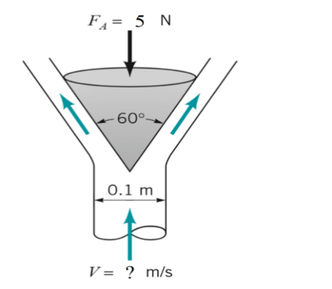Explain the global equation of integral form of conservation laws, then derives it into an mass conservation, linear momentum conservation, angular momentum conservation, and energy conservation! Also make the tables that performed during the class that shows the relation between them with the integral form of conservation laws!
2. A vertical, circular cross-sectional jet of water strikes a conical deflector as indicated in figure below. A vertical anchoring force of 5 N is required to hold the deflector in place. If the mass (kg) of the deflector is 0,5 kg. Determine the velocity of water entering the system.
3. 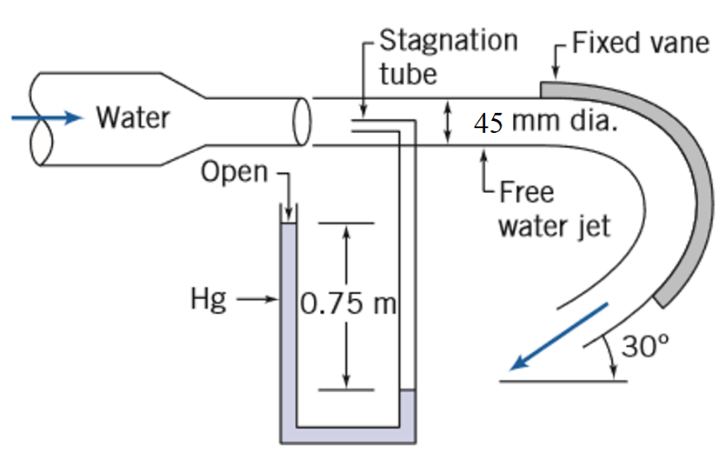A Stream of water from a 45-mm-diameter nozzle strikes a curved vane, as shown in figure below. A stagnation tube connected to a mercury-filled U-tube manometer is located at the nozzle exit plane.
   1. Calculate the speed of the water leaving the nozzle.
   2. Estimate the horizontal component of force exerted on the vane by the jet. Comment on each assumption used to solve this problem.

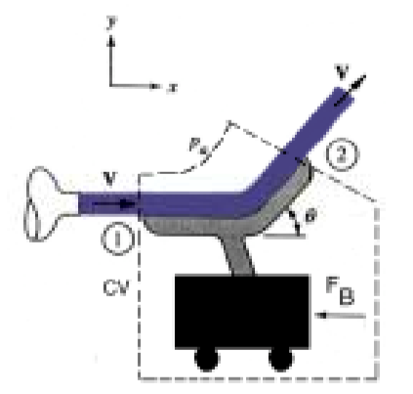

1. A water jet 5.5 cm in diameter with a velocity of 8 m/s is directed to a stationary turning vane with θ = 33o. **Determine the force FB** necessary to hold the vane stationary.

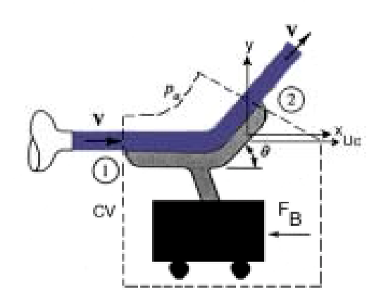Now consider the same problem but with the cart moving to the right with a velocity Uc = 3 m/s. Solve for **the value of braking force Fb** necessary to maintain a constant cart velocity of 3 m/s.

1. The wheeled cart shown rolls with negligible resistance. The cart is to accelerate to the right at a constant rate of 2.75 m/s2. This is to be accomplished by “programming” the water jet speed, V(t), that hits the cart. The jet area remains constant at 50 mm2. Find the initial jet speed, and the jet speed and cart speeds after 2.5 s and 5 s. Theoretically, what happens to the value of (V - U) over time?

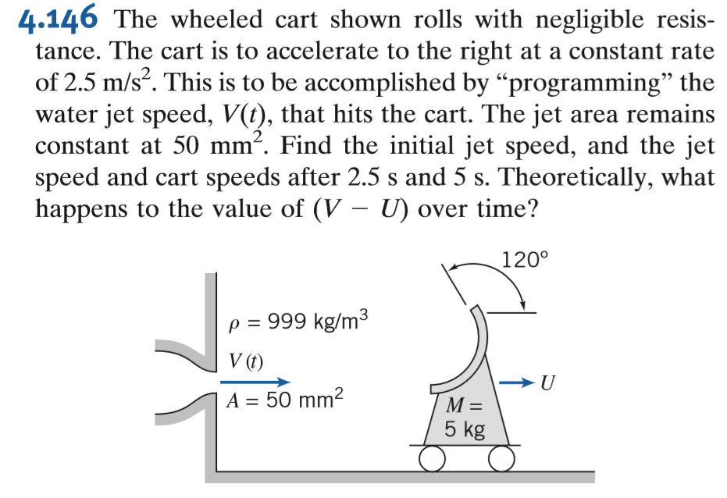

1. Water enters a rotating lawn sprinkler through its base at the steady rate of 3,25 m3/hour as shown in Figure below. The exit cross sectional area of each of the two nozzles is 25 cm2, and the flow leaving each nozzle is tangential. The radius from the axis of rotation to the centerline of each nozzle is 25 cm. Determine the resisting torque required to hold the sprinkler head stationary. Determine the resisting torque associated with the sprinkler rotating with a constant speed of 500 rpm. Determine the angular velocity of the sprinkler if no resisting torque is applied.

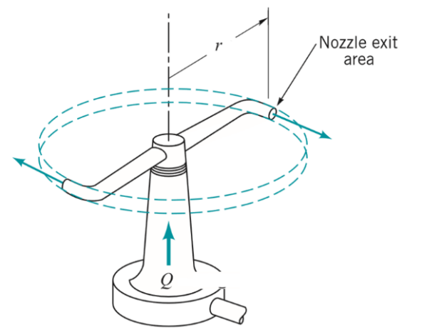

1. 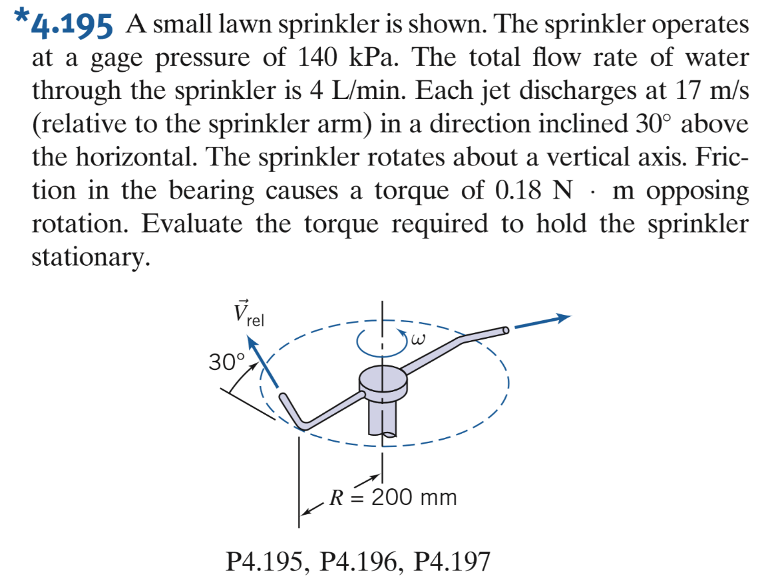A water torrent on the rooftop of FTMD which has a large diameter and it is fully filled with a height of 2 meters flows water to the sprinkler to irrigate the garden on the ground floor. It is known that each floor has a height of 3 meters. The sprinkler used has two jets, where each jet has a diameter of 2 mm pointing up at 30o from its horizontal axis. The bearing used causes 0.2 Nm of torque due to friction opposite to the direction of rotation.
2. Determine the amount of water flow (L / min) that will flow through the sprinkler (neglect the head loss of the system)
3. Based on the moment-momentum equation, determine the amount of the sprinkler rotation (RPM) that will occur
4. Calculate the area that will covers by water with this sprinkler
5. Figure below shows a schematic of a centrifugal pump. The fluid enters axially and passes through the pump blades, which rotate at angular velocity ω; the velocity of the fluid is changed from V1 to V2 and its pressure from p1 to p2.
6. Find an expression for the torque TO which must be applied to these blades to maintain this flow.
7. The power supplied to the pump would be P = ω TO. To illustrate numerically, suppose r1 = 0.2 m, r2 = 0.5 m, and b = 0.15 m. Let the pump rotate at 750 r/min and deliver water at 3.0 m3/s with a density of 1000 kg/m3. Compute the idealized torque and power supplied.

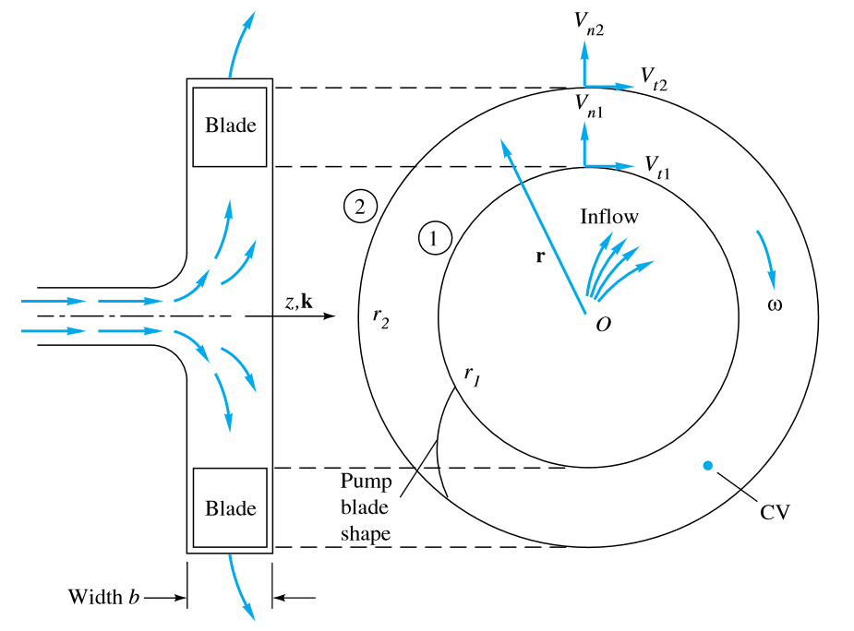

1. The turbine shown in Figure below develops 120 hp when the flowrate of water is 20 ft3/s. If all losses are negligible, determine (a) the elevation h, (b) the pressure difference across the turbine, and (c) the flowrate expected if the turbine were removed.

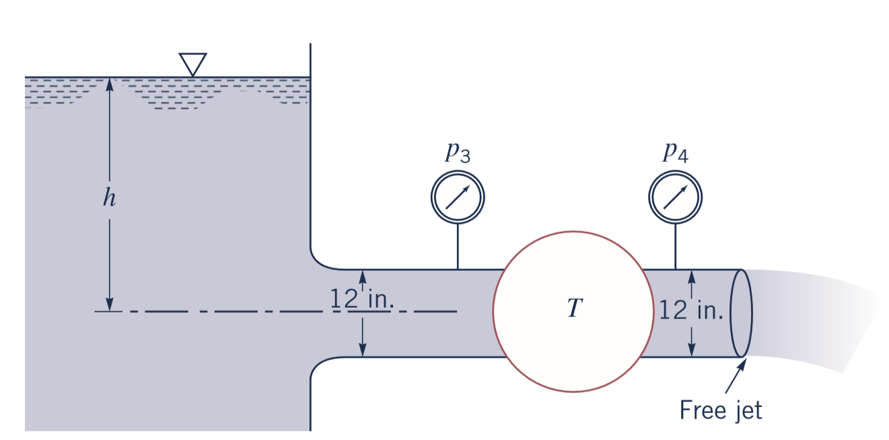

1. Water is to be moved from one large reservoir to another at a higher elevation as indicated in Figure below. The loss of available energy associated with 2,5 ft3/s being pumped from sections (1) to (2) is loss = 25*V̅*2/2 ft2/s2, where *V̅* is the average velocity of water in the 8-in. inside diameter piping involved. Determine the amount of shaft power required

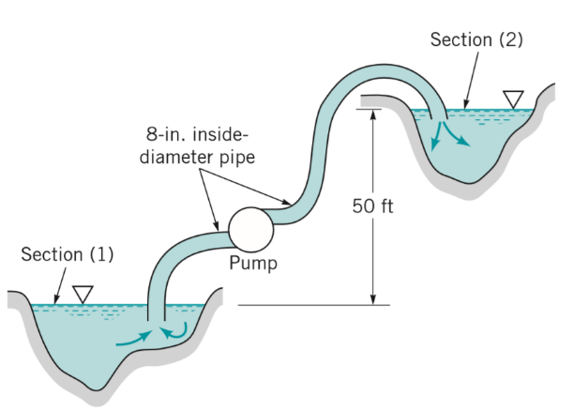

**Good Luck**